Problem at hand: Mgr Override account number (for old mgr override) does not carry over on IO recovery load, and consequently, the xmission file. This has nothing to do with the second level override you just added, this only pertains to the old override.

What this means is users are not getting paid!!

User record in question:

Load was entered by Darrel Newby, account number overeride 0008865.

http://jrc1.jrcdispatch.com/JRCADMIN/Users/tabid/67/ctl/Edit/mid/385/ItemID/163/Default.aspx

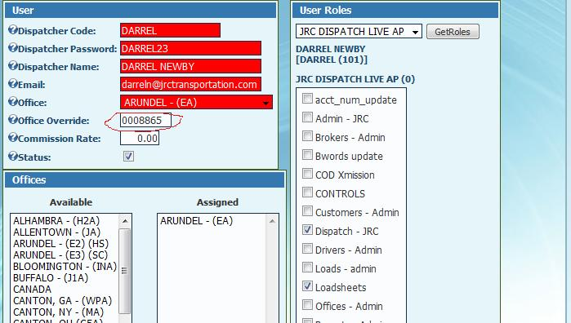

Source IO load, Daryl entered load EX01400, the account number to be paid is correctly shown as 0008865, amount $16.54.

http://jrc1.jrcdispatch.com/ViewLoads/tabid/70/ctl/Reports/mid/380/ReportType/LoadReport/ItemId/239969/LoadType/IO/Default.aspx

Source load shows correct account number override for the user who entered the load, 0008865.
8865 is the users account number override, so the office number isn't used.

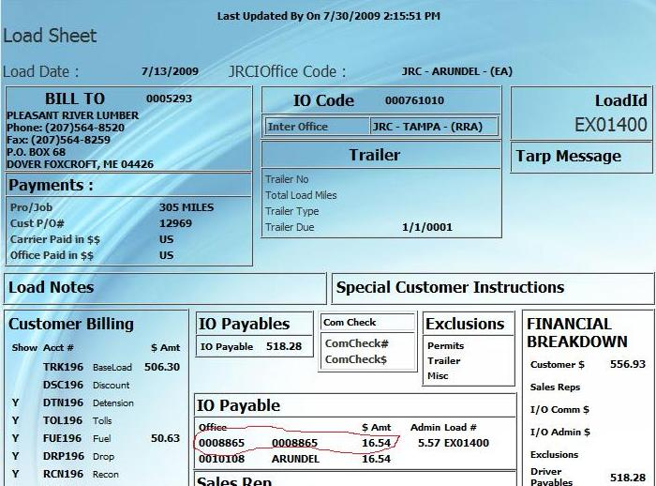

Recovered load:

http://jrc1.jrcdispatch.com/ViewLoads/tabid/70/ctl/Reports/mid/380/ReportType/LoadReport/ItemId/239978/LoadType/BK/Default.aspx

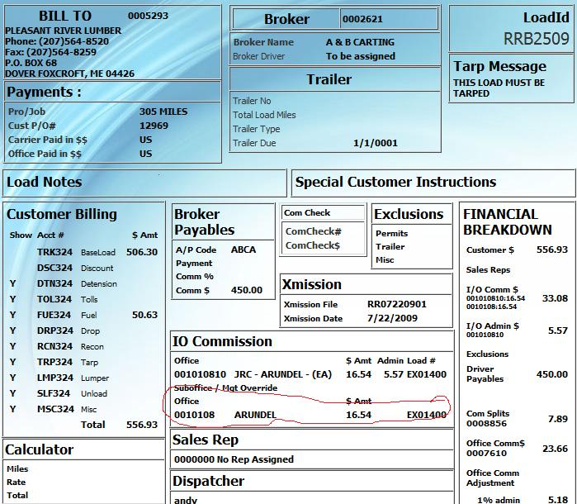
The IO recovered load doesn't bring in the correct account number on recovery. It only brings in the office number, not the account number override that was shown correctly on the source load. See area circled in red.

Resulting Xmission:

Consequently: these users have not been getting paid for months. Their commissions have been paid only to 0010108 because no contingency was made in xmission to accomodate account number override. Bascially, you have been paying the office but not the user.

"HDR","RRB2509","07/22/09","S","00","0005293","ABCA","01/01/01","12969 ","A","07/13/09",556.93,"ABCA ","305 MILES ","EX01400 BONDSVILLE, MA "," "," "," "
"DT4","RRB2509",4,"01","** PICK-UP DOVER FOXCROFT,ME, "
"DT5","RRB2509",5,"0007610",0,0,0,"23.66"
"DT5","RRB2509",5,"0010108",0,0,0,"16.54"
"DT5","RRB2509",5,"0010108",0,0,0,"16.54"
"DT5","RRB2509",5,"0008856",0,0,0,"7.89"
"DT5","RRB2509",5,"TRK324B ",1,"506.30","506.30","450.00"
"DT5","RRB2509",5,"FUE324B ",1,"50.63","50.63",0
"DT5","RRB2509",5,"999",0,0,0,5.180
"DT4","RRB2509",4,," "," "
"DT4","RRB2509",4,," "," "

